|  |
| --- |
| Utah Education Network RFP |
| NetSpective Proposal |
| Reference Number W110428 |

|  |
| --- |
|  |

Table of Contents

Tab A – Letter of Transmittal 3

Tab B – Executive Summary 5

Tab C – Section 3 – Specifications 6

3.00 Specifications 6

3.01 Deployment Methods 6

NetSpective Passive Appliance 6

NetSpective Software as a Service Deployment 10

3.02 Scalability 11

3.03 LDAP Integration 11

3.04 URL Filtering 12

Overrides 12

Web Search Term Override 12

Category List 13

Process of Website Categorization 21

Process of Reporting Uncategorized/Incorrectly Categorized Websites 21

3.05 SSL Filtering 21

HTTPS / SSL Blocking 21

3.06 CIPA Compliance 22

3.07 Management Interface 23

3.08 Clustering 25

3.09 Protocols and Applications Control 25

3.10 Safe Search Enforcement 25

3.11 YouTube for Schools 25

3.12 Block page Customization 26

3.13 Reporting 26

NetAuditor Security Event Manager 26

3.14 Diagnostic and Troubleshooting Features 29

On the Box Statistics 29

Diagnostic Tool 30

3.15 Support 30

3.16 Additional Features 31

Referrer Depth 31

Abuse Detection 31

Override Request 31

3.17 Price 32

3.18 References 32

Tab D – Cost Proposal 33

Tab E – Financial Reports 38

# **Tab A – Letter of Transmittal**

TeleMate.Net Software is a global leader in providing scalable network monitoring and security solutions. Our product families including, TeleMate™ Unified Call Management, NetSpective™ Content Filter, and NetAuditor™ Event Manager are considered products of choice for many Federal, State, Local, Educational, and Fortune 1000 institutions.

TeleMate.Net Software is proud to highlight our accomplishments as delivering easy to use, fully automated, highly reliable and lowest total cost of ownership solutions in the industry. TeleMate.Net Software accomplishes this by listening to customers and delivering scalable solutions to the IT professional that is being stretched. These tools increase productivity, allowing the IT professional do more with less, enabling ROI measured in months in many cases. Organizations of all sizes use TeleMate.Net Software products to help control and recover network costs, improve employee productivity and enhance network security. Every customer is a reference customer.

Since 1986, TeleMate.Net Software has evolved its core reporting technology, incorporating the latest advances in database, reporting, user-interface, and categorization technologies, to become the dominate force in addressing telecommunications administrators core requirements for Unified Call Management. In 1996, TeleMate.Net Software extended the company's market presence by introducing the world's first patented integrated voice and data reporting platform for monitoring PBXs, voice managers, firewalls, intrusion detection sensors, web servers, and mail servers. Continuing our leadership position TeleMate.Net Software introduced NetSpective™ Content Filter in 2001 as the need for real-time enforcement of network usage policies became evident. Today, innovation continues with complete integration into directory services and real-time notification and reporting.

Since the original inception of TeleMate.Net Software the company has over 18,000 installations worldwide. The success of the technology TeleMate.Net Software develops and services has been driven by recognizing trends and providing solutions that seamlessly integrate with technology from leading manufacturers including but not limited to Cisco Systems, AVAYA, Nortel, NEC, Siemens, ShoreTel, Asterisk, Microsoft, Symantec, Juniper Networks, Check Point Software, and Novell.

Our ability to listen and respond rapidly to customers' requirements and specifications has earned a credible and solid reputation amongst our customers. Our customers have told us the level of customer service they receive is second to none. Our 'top down' approach to the market is to make every customer a reference account by listening and then delivering scalable, feature rich solutions that are easy to use.

[](http://www.telemate.net/)

|  |  |  |
| --- | --- | --- |
| **Person of Contact** | **Technical Writer for RFP** | **Authorized to Sign Contract** |
| **James Wooden**  *Regional Sales Manager/Federal Sales Director,* TeleMate.Net Software  5555 Triangle Parkway Suite 150 Norcross, Georgia 30092  Direct: 678-589-0016  Cell: 678-923-0016  Cell: 678-481-2876  Fax: 678-589-7110  [james.wooden@telemate.net](mailto:james.wooden@telemate.net) | William Babij  *Sales Engineer,* TeleMate.Net Software  5555 Triangle Parkway Suite 150 Norcross, Georgia 30092  Direct: 678-589-3630  Cell: 860-707-5216  Fax: 678-589-7110  [william.babij@telemate.net](mailto:william.babij@telemate.net) | John O’Reilly  *President,* TeleMate.Net Software  5555 Triangle Parkway Suite 150 Norcross, Georgia 30092  Direct: 678-589-3524  Cell: 770-331-9769  Fax: 678-589-7110  [john.oreilly@telemate.net](mailto:john.oreilly@telemate.net) |

**Request for Proposal Reference Number W110428**

# Tab B – Executive Summary

**NetSpective** is a sophisticated Internet content filtering appliance that maximizes the performance and security of your data network by eliminating undesirable web traffic. Its rack-mount configuration easily connects to your network, and its filtering and operational controls are simple and flexible. The web hosted interface provides real-time status updates and control, including compliance with federal filtering mandates and communications tracking requirements.

As a **Passive or Transparent** filter NetSpective prevents network performance degradation. SideScan™ is a firewall-independent filtering technology designed into NetSpective that reviews every packet of information going out to the web, including HTTP, HTTPS, FTP, NNTP, chat, peer-to-peer, Skype™, VoIP, and streaming media, and interrupts connections to websites or file sharing applications that have been blocked

The signature based inspection incorporated into SideScan enables a single NetSpective appliance to scale to support unlimited users in large networks as well as distributed networks leveraging NetSpective's ability to selectively replicate policy and device settings.

As a **Software as a Service (SaaS)**, NetSpective is capable of filtering and reporting on traffic both on and off the network, through the use of Remote Agents.

Security concerns and legal liability of threats caused by remote users increase sharply as computers leave your network's border security. Malware, spyware, phishing sites, closed P2P applications like Skype and proxy avoidance tools like Ultra Surf are the typical culprits. NetSpective's Remote Agent technology enforces internet policies regardless of physical location.

Installed at the socket level in Windows and Mac operating systems, agents protect and log all remote user Internet activity, are password protected, and provide a complete audit trail of all internet activity.

**NetAuditor** expands network security event management (SEM) strategies beyond basic end-point protection by accelerating the detection and automated response that leading firewall manufacturers omit in their border security offerings. NetAuditor includes automatic end-user identity association, geographic location identification by region; country; and service provider, Internet content categorization, real-time monitoring, and network event triggers.

[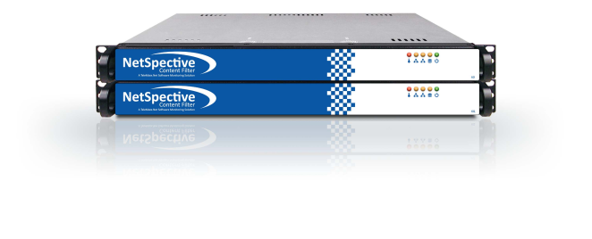](http://www.getnetspective.com/products/netspective/)

# Tab C – Section 3 – Specifications

TeleMate.Net Software acknowledges sections 2.14 through 2.41, understood and agreed.

## 3.00 Specifications

## 3.01 Deployment Methods

### NetSpective Passive Appliance

With our Passive approach, we hang off the SPAN or Mirror port of a switch monitoring all requests the internet. With this we are not a point of failure on the network and do not introduce any added latency. We do support multi-appliance load balancing and hot spare failover scenarios for redundancy.

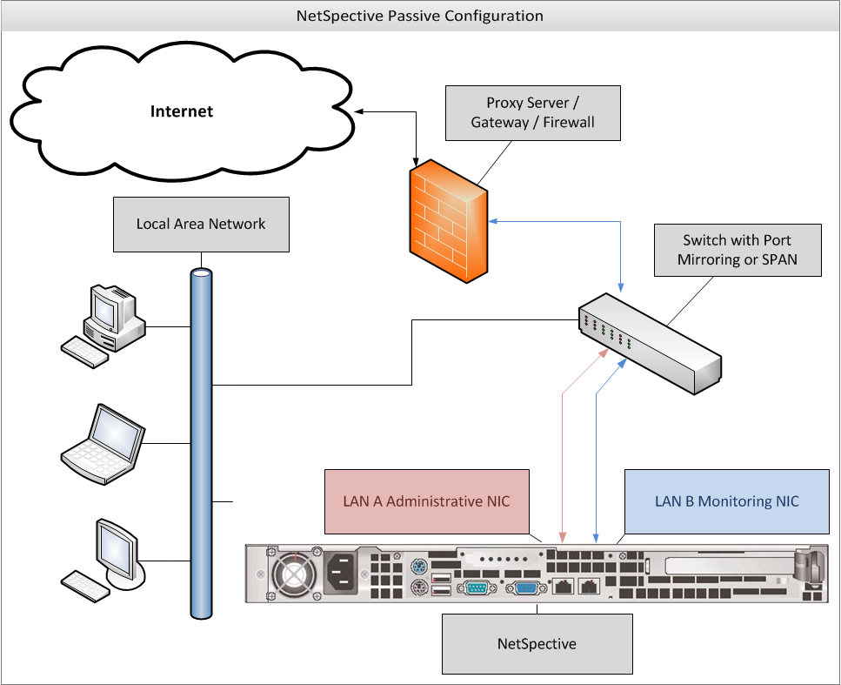

#### Authentication/Deployment Strategies for Passive Appliance

#### NetSpective Logon Agent

Designed as a domain based technology, our logon agents are used to filter desktops and notebooks on the LAN. Our logon agents support Windows, Citrix Terminal Servers, as well as Max OS X desktops and notebooks. Logon Agents typically sit on the domain controller and execute through a Group Policy Object (GPO) or Network Logon Script. They can be run with a number of parameters.

In persistent mode, logon agents would stay up and running on the user’s workstation, sending NetSpective username and IP address association periodically. This is helpful for notebooks which may be on a wireless connection and their IP address may change over time.

In non-persistent mode, the logon agent would run and terminate in about a millisecond, just sending the username and IP address association once.

In the silent mode, the logon agent can be completely hidden as a service. This is for preventing students from being aware of its existence, and thus being unable to remove or terminate the agent.

#### NetSpective Remote Agent

Our Remote Agents are designed for filtering and reporting on Windows and Mac OS X notebooks both on and off network. When installed on the user’s notebook, the remote agent will communicate back to the NetSpective appliance asking for a ‘Go’ or ‘No-Go’ on the user’s web traffic using a proprietary UDP packet. The appliance then checks against the user’s policy and sends that packet back to the remote agent to either allow the traffic or redirect to a block page. The user’s surfing history logs are sent back to the appliance periodically. Even if communication to the appliance is interrupted, the remote agent will hold log files until connection is restored. Our remote agents work intelligently alongside our logon agents and will deactivate themselves when the presence of the logon agent is detected so users on the LAN do not send logon information multiple times.

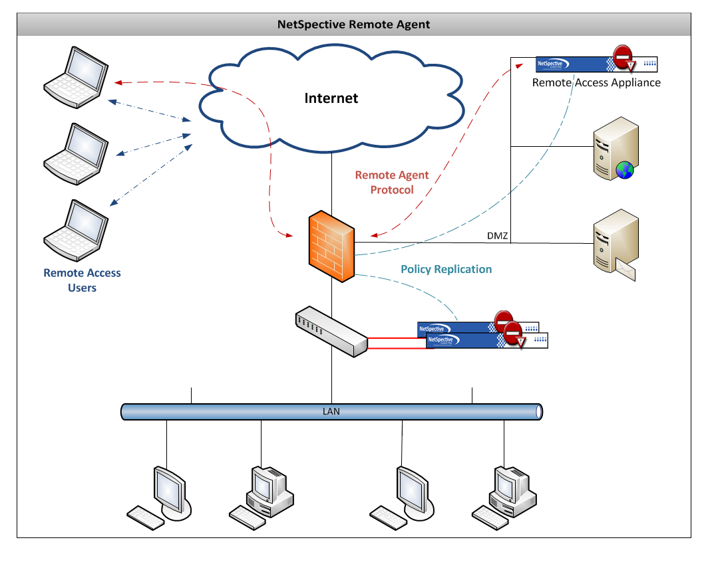

Image depicts an example of how the Remote Agent can operate. Remote Agent technology only requires one appliance so long as the appliance has an internal LAN IP address and an IP address outside of the network.

#### Mobile Portal and Mobile Portal with Pairing

The Mobile Portal was designed under HTML5 to be web browser and operating system independent. This is primarily used to filter mobile devices on the LAN such as iPhones, iPads, Android Phones, and various tablets. With the mobile portal we can authenticate users with LDAP or transparently with Windows NTLM.

Through Mobile Portal with Pairing, we can pair a device to a user either temporarily or permanently if you choose. This is popular in school libraries where iPads are being issued out much like checking out a book. This feature also supports Pairing by Request. Guest users can encounter the same portal page, but request a temporary pairing. Through this you can specify a policy to put guest users under as well as the length of time you wish to give them access. Mobile Portal with Pairing users can be further managed through the Mobile Pairing menu.

#### NetSpective Mobile Browser

Found on the Apple Store, our NetSpective Mobile Browser was designed as a mirror of Safari in layout and feel. This mobile browser is used to filter iPads both on and off network. Built into the mobile browser is our same remote agent technology. iPads can be identified either by LDAP authentication or by device name. The mobile browser also supports the ability to identify filename extensions that you may wish to open as attachments.

#### NetSpective Wireless Agent

Alternate methods of binding User ID to IP Addresses have been developed and are available based on customer requirements. For environments that utilize authentication at the wireless access point, NetSpective deployments can be customized to dynamically bind DHCP log and Access Control Server logs (RADIUS logs).

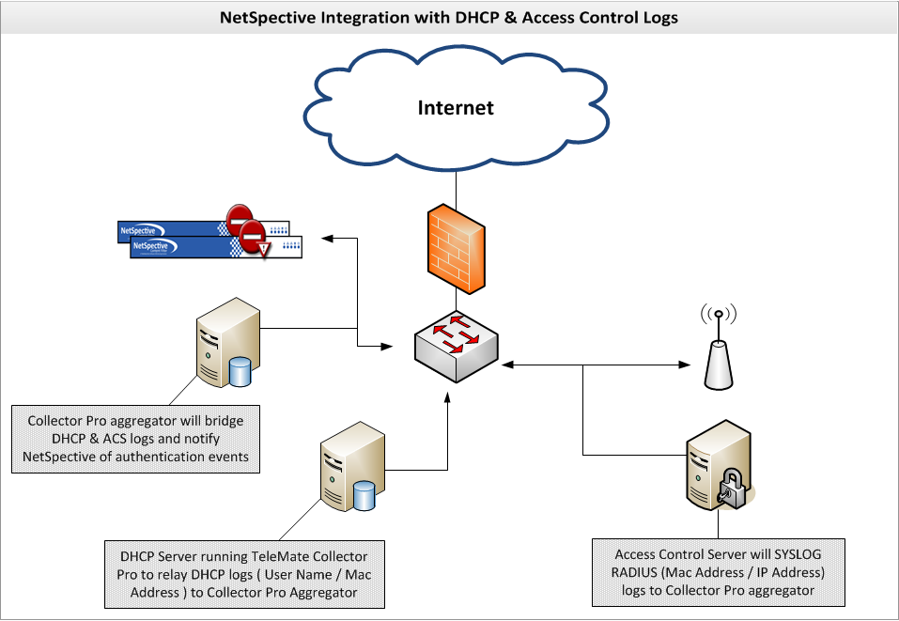

### NetSpective Software as a Service Deployment

As a SaaSdeployment, NetSpective is capable of filtering and reporting on traffic both on and off the network, through the use of Remote Agents. With our solution hosted in the cloud, users can run our Remote Agent to enforce filtering policy and send browsing history for reporting. LDAP integration for users, groups, and managers can be provided by request and is provided by professional services. LAN specific authentication strategies such as the Logon Agent and Mobile Portal are only supported with an on the premise appliance and are not available with our SaaS solution.

While NetSpective should not require any firewall changes so long as all network traffic is seen by the mirror or SPAN port, communication to our servers for category and product updates is needed. Below is a list of the IP address ranges and ports that NetSpective uses.

|  |  |
| --- | --- |
| Port Numbers for NetSpective Communication | |
| IP Address Ranges | 67.220.101.128/28 |
|  | 209.208.242.16/28 |
| For the above ranges the NetSpective appliance will need access to the following protocols/ports | |
| Administration | TCP 80 & TCP 443 |
| Block Page | TCP 8080 |
| Portal | TCP 81 |
| Logon Agent | TCP 2020 & UDP 2020 |
| Terminal Server Agent | TCP 2050 & UDP 2050 |
| Remote Agent | TCP 3001 & UDP 3001 |
| FTP | TCP 21 |
| NTP | UDP 123 |

NetSpective will not require any access to the provider’s network to operate properly. We understand the requirements of this deployment would put appliances at the downstream locations only. For example, we would require an appliance at each pipe going out to the internet. If a school or library only has one internet connection, then they would only need one appliance to have their entire network filtered. In the case of Software as a Service, we would need to install a Remote Agent on each Windows or Mac OS X computer that the customer wishes to filter.

## 3.02 Scalability

|  |  |  |  |
| --- | --- | --- | --- |
| Solutions | Number of Concurrent Users Supported | Bandwidth Capacity | Network Interface Types Supported |
| NetSpective Passive 6D Appliance | 250 users up to 5000 concurrent users | 1Gig Bandwidth | Ethernet |
| NetSpective Passive 6Q Appliance | Unlimited Users | 1Gig Bandwidth | Ethernet |
| NetSpective Passive 10 Gig 6Q Appliance | Unlimited Users | 10Gig Bandwidth | Ethernet or Fiber Optic Interface |
| NetSpective Software as a Service | Unlimited Users | 1Gig Bandwidth | N/A |

## 3.03 LDAP Integration

NetSpective can support Active Directory, eDirectory, and Open Directory. We typically only require user access to the directory, not admin rights. The appliance can support any number of LDAP sources as well as any combination you wish to use together.

Our various authentication strategies and agents are outlined in Section 3.01 under Authentication/Deployment Strategies for Passive Appliance.

## 3.04 URL Filtering

### Overrides

Overrides may be created to allow, block, or categorize specific web sites, news groups, IP addresses, web search terms, or file types. The different types of overrides are grouped together on different pages. Overrides can be imported from a simple text file as well.

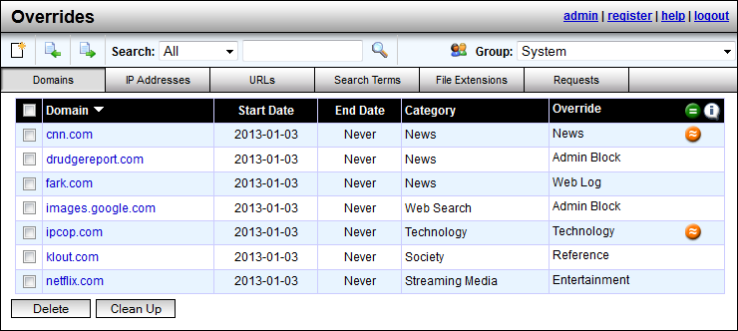

The Exempt group is never blocked and is exempt from all overrides. All other groups, including the Public group, have their own override lists. Additionally, system-wide overrides may be created. System level overrides are processed first and affect all groups except the Exempt group.

### Web Search Term Override

The web search term override feature is used to assign terms or combinations of terms used at search engines to a specific category. This feature in itself is a method of preventing a user from finding objectionable content. In addition, when a term is assigned to an abusive category that is blocked, it also triggers the abuse detection feature. Thus, a user searching for abusive content can also be given an abuse lockout.

### Category List

**User Defined Categories**

These are categories you can create yourself and populate with anything you with through the use of the ‘Overrides’ section of the product, which can be seen in section 3.04 of this proposal.

**Advertising**

Sites that provide banner advertising servers.

<HTTP://googleadservices.com/>

<HTTP://ad.doubleclick.net/>

**Alcohol**

Sites promoting alcohol use, including drink recipes, home brewing methods, advertisements, etc.

<HTTP://www.captainmorgan.com/>

<HTTP://www.greygoose.com/>

**Anonymous Proxy & Hacking**

Sites specifically designed to bypass content filters and security. Promotion, instruction, or advice on the questionable or illegal use of computer equipment and software.

<http://unblocksites.com/js/>

<http://myyoutubeunblocker.com/>

**Art**

Sites providing online galleries, museums and artist sites.

<HTTP://www.vangoghgallery.com/>

<HTTP://www.leonardoda-vinci.org/>

**Automotive**

Sites of automobile manufacturers, dealers, sales and clubs.

<HTTP://www.hyundaiusa.com/>

<HTTP://www.nissanusa.com/>

***Browser Protection***

**Malware**

Sites that attempt to interfere with normal computer functions and/or send personal data about you to unauthorized parties over the Internet. Only Admin Allow can override this category.

**Phishing**

Sites that impersonate another site in an attempt to mislead you into providing personal information. Only Admin Allow can override this category.

**Certificate Authority**

<HTTP://ocsp.godaddy.com/>

<HTTP://ocsp.verisign.com/>

**Chat**

Sites and protocols related to Instant Messaging and Chat applications.

<HTTP://www.aim.com/>

<HTTP://www.google.com/talk/>

**Chat Extended**

Sites and protocols related to additional Instant Messaging features such as, File Sharing, Voice over IP, Streaming Internet Radio Video Messaging, etc.

74.125.137.113

173.194.37.33

***Chat Protocols***

AOL

ICQ

IRC

Jabber

MSN

MySpace

Yahoo

**Consumer Information**

Sites with consumer-generated reviews, buying tips, ratings and pricing.

<HTTP://www.kbb.com>

<HTTP://www.consumerreports.org>

**Criminal Skills**

Sites advocating, instructing, or giving advice on performing illegal acts.

<HTTP://www.gregmiller.net/locks/>

<HTTP://www.lockpickguide.com/>

**Cult and Occult**

Sites promoting cult or occult matters and other types of psychological control or manipulation.

<HTTP://tsl.org/>

<http://krishna.org/>

**Drugs**

Sites promoting the use or purchase of illegal drugs and narcotics, including techniques and products.

<http://www.rollitup.org>

<HTTP://greenpartypills.com/>

**Dynamic Hosting**

Sites for third party content provider networks that service a wide range of frequently changing content using a distributed network of servers.

<http://www.godaddy.com/>

<HTTP://us.bc.yahoo.com/b>

**Education**

Sites sponsored by schools or other educational facilities, faculty or alumni groups that promote educational events or activities.

<HTTP://mathtag.com/>

<HTTP://educationbug.org/>

**Entertainment**

Sites containing movies, theater times, comic strips, television, music, hobbies, rock bands, etc.

<HTTP://www.imdb.com/>

<HTTP://www.rottentomatoes.com/>

**Finance/Investing**

Sites of financial trade, financial news, online banking services, trading exchanges.

<HTTPS://us.etrade.com:443>

<HTTP://www.tdameritrade.com/home.page>

**Gambling**

Sites which encourage gambling such as betting sites, bookmaker odds, lottery, bingo, online sport betting, and online casinos.

<HTTP://www.onlinegambling.com/>

<HTTP://www.netbet.org/>

**Games**

Sites related to computer or other games, game download and online game sites.

<HTTP://battle.net/wow>

<https://www.guildwars2.com/en/>

**General Business**

Sites sponsored by or devoted to individual business firms.

<http://listingbook.com/home/>

<http://www.insperity.com/>

**Glamour**

Sites related to fashion and modeling.

<http://www.fashion.net/>

<http://www.elle.com/fashion/>

**Government**

Sites sponsored by government branches or agencies.

<http://www.fbi.gov/>

<http://www.irs.gov/>

**Hate Speech**

Sites containing material related to the discrimination of any group of people based on race, religion, gender, nationality, sexual orientation, etc.

<HTTP://www.kkk.com/>

<http://kkk.bz/>

**Health**

Sites that provide information or advice on personal health or medical services, health insurance, procedures, or devices. This includes information such as diet, nutritional facts, therapies and counseling services.

<http://www.redcross.org/>

[http:/www.gwinnettmedicalcenter.org/](http://www.gwinnettmedicalcenter.org/)

**Hobbies**

Sites that provide information on private and largely sedentary pastimes.

<http://www.modelairplanenews.com/>

<http://www.modelaircraft.org/>

**Hosting Site**

Sites for third party content provider networks that service a wide range of frequently changing content using a distributed network of servers.

<HTTP://www.hostgator.com/>

<HTTP://www.namecheap.com/>

***HTTPS / Direct Connections***

**HTTPS Trusted**

HTTPS sites with verified certificates signed by a trusted Certificate Authority that don’t fall within a current category.

**HTTPS Untrusted**

HTTPS sites with self-signed, invalid, or expired certificates.

**HTTPS Unrated**

HTTPS sites not seen before that will be processed within 24 hours and moved to an appropriate category. (Passive / Remote Agent only)

**Internet Tools**

Sites or services that give users the ability to store personal information or remotely access Web-Conferencing.

<HTTPS://spreadsheets.google.com:443>

<HTTP://docs.google.com/>

**Job Search**

Sites that offer information on or support seeking employment.

<HTTP://www.monster.com>

<http://www.dice.com/>

**Law**

Sites with legal content to include laws, legal topics and lawyers.

<http://www.splcenter.org/get-informed/intelligence-files/ideology/ku-klux-klan>

<http://www.laws.com/>

**Lingerie**

Sites selling or modeling undergarments or lingerie.

<http://www.victoriassecret.com/>

<http://www.fredericks.com/>

**Mature Content**

Sites with mature content that may not be considered explicitly pornographic- like lingerie, swimsuits and revealing pictures.

<http://www.maxim.com/>

<http://www.fhm.com/>

**Military**

Sites sponsored by military branches or agencies.

<http://www.military.com/>

<http://www.militarytimes.com>

**News**

Sites relating to mainstream online news publications or media format such as print, radio, or television.

<http://www.cnn.com/>

<http://www.foxnews.com/>

**Not Rated**

Sites that don't fall into a specific category.

**Nudism and Naturism**

Sites related to nudists and naturists.

<HTTP://www.truenudists.com/>

<HTTP://www.aanr.com/world-of-nude-recreation>

**Peer-to-Peer**

Sites and protocols related to file sharing applications. example: KaZaa and Gnutella.

<HTTP://www.kazaa.com/>

<http://www.bittorrent.com/>

***Peer-to-Peer Protocols***

Ares

BitTorrent

Direct Connect

EDonkey

Freegate

Gnutella

Kazaa

Napster

Pando

Piolet

The Onion Router

Ultra Surf

WinMX

**Personals/Dating**

Sites related to personal ads, dating sites and services, relationships, introductions.

<HTTP://www.eharmony.com/>

<HTTP://www.pof.com/>

**Politics & Religion**

Sites that pertain to politicians, election campaigns, political organizations and publications, churches and related publications, discussion forums, religions.

<HTTP://www.scientology.org/>

http://www.buckheadchurch.org/

**Pornography**

Sites with nudity of any sort, vulgarity, including the likes of Playboy, Hustler, Penthouse, etc.

<http://www.playboy.com/>

<http://penthouse.com/>

**Portal**

Site or service that offers a broad array of resources and services, such as e-mail, forums, search engines, and on-line shopping malls.

<HTTP://www.yahoo.com/>

<HTTP://aol.com/>

**Reference**

Personal, professional, or educational references to include online dictionaries, maps, and language translation sites.

<HTTP://dictionary.com/>

<HTTP://mapquest.com/>

**Remote Login**

Sites hosting Remote Login tools.

<HTTPS://secure.logmein.com:443>

<https://secure.logmein.com/products/hamachi/download.aspx>

***Remote Login Protocols***

OpenVPN

SSH

VNC

Citrix

Remote Desktop

PCAnywhere

**Science**

Sites whose primary function is to provide scientific/research pages or materials.

<HTTP://www.billnye.com/>

<HTTP://www.scires.com/>

**Sex Education**

Sites offering information on sexuality and sexual content.

<HTTP://www.advocatesforyouth.org/>

<HTTP://www.plannedparenthood.org/>

**Sexual Advice**

Information related to sexual relationships and sexual issue.

<HTTP://www.thefrisky.com/>

<http://www.yourtango.com/>

**Sexual Orientation**

Sites related to the discussion of homosexuality or other sexual orientation issues.

<HTTP://www.glaad.org/>

<http://www.gaycenter.org/>

**Shopping**

Sites which contain consumer oriented online shopping, online malls, real estate, automobiles, classifieds and online trading services.

<http://www.amazon.com/>

<http://www.hottopic.com>

**Shopping Auction**

Shopping sites that specifically conduct their shopping business as auctions.

<HTTP://ebay.com/>

<HTTP://www.shopgoodwill.com/>

**Society**

Sites that provide information on matters of daily life including sites that contain material relative to an individual's personal life, whether straight, gay, lesbian, or otherwise; any site pertaining to any particular culture, behavior, organization, society, club, etc.

<https://www.facebook.com/>

<https://twitter.com/>

**Society Plugin**

Examples such as ‘Like’ buttons, Google+ ‘+1” buttons, and ‘Share on Twitter’ buttons.

**Sports**

Sites that provide information on or promote sports, active games, and recreation.

<http://www.nfl.com/>

<http://www.nhl.com/>

**Streaming Internet Radio**

Sites that transmit audio in real-time (i.e., as the information is received).

<http://www.pandora.com/>

<http://www.shoutcast.com/>

**Streaming Media**

Sites that stream audio and video on demand.

<http://www.youtube.com/>

<http://www.hulu.com/>

***Streaming Media Protocols***

Flash

QuickTime

Real

Slingbox

Winamp Shoutcast

Windows Media

**Technology**

Sites dedicated to general computer/internet related information pertaining to both hardware and software.

<http://www.dell.com/>

<http://www.asus.com/>

**Tobacco**

Sites that provide information on, promote, or support the sale of tobacco products, and any associated paraphernalia.

<https://camel.tobaccopleasure.com>

<https://www.marlboro.com>

**Travel**

Sites that offer travel tickets and reservations, travel clubs, travelogues, visitor information bureaus, travel promotions, etc.

<http://www.travelocity.com/>

<http://www.priceline.com/>

**Violence**

Sites that provide information on or promote violent activity.

<http://www.facesofdeath.com/>

***Voice Over IP***

SIP

NetMeeting H.323

Skype

**Weapons**

Sites that provide information on, promote, or support the sale of weapons and related items.

<http://www.weapons-universe.com/>

<HTTP://www.gunsmagazine.com/>

**Web E-Mail**

Site that allow users to send e-mail via a web browsing application including sites such as hotmail.com and Yahoo! mail.

<HTTPS://gmail.com>

<https://login.secureserver.net/>

**Web Log**

(also known as blog) Site that serves as a publicly-accessible personal journal for an individual. Typically updated daily, blogs often reflect the personality of the author.

<HTTP://www.blogger.com/>

<http://googleblog.blogspot.com/>

**Web Search**

Sites that support searching the Web, news groups, or indices and directories thereof.

[www.google.com](http://www.google.com)

<www.bing.com>

**Web Search Filtered**

Sites that support searching the Web, news groups, or indices and directories thereof. These engines will not return objectionable content or explicit pictures. Safe search options are enforced via this category for Google, Bing, MSN, Yahoo, Hotbot, Lycos, Ask, and Dogpile.

### Process of Website Categorization

NetSpective handles categorization in several ways. We use category lists from a number of different vendors. We realize that each vendor has its strengths and weaknesses from one category to the next, thus we pick and choose which lists we use from each vendor.

For more sensitive and ever changing sites, we have proprietary web crawlers constantly searching the internet and evaluating each website. Due to sensitive sites such as Anonymous Proxy and Hacking or Pornography changing on a day to day basis, we utilize a feature referred to as our Micro Updates. With this, unknown websites that are detected by the NetSpective appliance are sent back to TeleMate.Net for evaluation. TeleMate.Net’s web crawler will then categorize the URL and send it back out to all NetSpective Appliances in distribution every 10 minutes. This gives each customer the benefit of learning from our entire customer base.

Lastly, any category overrides a customer makes on their appliance is communicated back to TeleMate.Net. TeleMate frequently has human eyes combing over these customer overrides and evaluating their category listing. If we make any changes to these websites, those changes will be reflected in the Overrides section of the product so you may see what we agreed upon or disagreed with. Any URLs that we changed to match your overrides can be cleared out easily with the ‘clean up’ button so the administrator does not have to review them.

### Process of Reporting Uncategorized/Incorrectly Categorized Websites

In addition to our Micro Updates for updating malicious and sensitive content every 10 minutes, there are other ways of communicating corrections to TeleMate.Net. As mentioned before, all custom whitelist and blacklist ‘overrides’ are communicated back to TeleMate.Net for human review. There is also a link on the [TeleMate.Net Website](http://www.telemate.net/services/support/url_review.php) where customers can manually request a website’s category be reviewed and changed. Any changes made to these categories will be updated with our ‘Category Master List’ which typically happens daily at midnight or when the customer chooses to set their automatic updates within the appliance’s administration interface.

## 3.05 SSL Filtering

### HTTPS / SSL Blocking

In Passive mode, NetSpective monitors the network for particular signatures much like an intrusion detection product. Since HTTPS tunnels HTTP sessions over SSL, NetSpective detects the SSL connection and takes actions based on the categorization of the HTTPS/SSL server.

If the IP address of an HTTPS/SSL server is categorized and the policy is set to block, then all HTTPS and other SSL connections to it are blocked. Therefore, an objectionable site cannot be accessed via HTTPS (port 443 or otherwise), SSH, or any other protocol based on SSL.

NetSpective also utilizes the adaptive filtering process for public SSL sites. When the appliance detects uncategorized SSL accesses on port 443, the site is temporarily categorized as "HTTPS Unrated" and then uploaded to the Adaptive Filtering Lab for categorization.

The NetSpective Adaptive Filtering Lab will categorize the site based on the following criteria:

* If the site's SSL certificate is invalid, self-signed, or signed by an untrusted certificate authority, then the site will be categorized as "HTTPS Untrusted".
* If the site's SSL certificate is valid, signed by a trusted certificate authority, and the site cannot be categorized, then the site will be categorized as "HTTPS Trusted".
* If the site's SSL certificate is valid, signed by a trusted certificate authority, and the site can be categorized, then the site will be categorized as a specific category (for example, "Mature Content"). Thus, blocking "Mature Content" would block HTTP and HTTPS traffic to the site.

This method of filtering is global on every appliance. However if you choose, you can enable or disable the following categories on a group by group basis.

* HTTPS Trusted
* HTTPS Untrusted
* HTTPS Unrated

## 3.06 CIPA Compliance

CIPA requires schools and libraries with computer Internet access to certify that they have Internet safety policies and technology protection measures, e.g., software filtering technology, both on and off network, to receive discounts for Internet access and internal connections under the schools and libraries universal service support mechanism.

NetSpective® is the only CIPA-compliant URL filtering appliance that prevents access to both P2P sites and P2P applications, effectively ensuring the safety and security of a school or library's network.

The NetSpective Solution is highly flexible and easily customizable; with a database that includes over a million URLs grouped into over 120 categories that is dynamically updated to provide the most accurate and current information available. It easily lets you monitor, block or report on:

* + URL visits
  + Use of streaming media and audio files, and their Web sites
  + Use of Peer-to-Peer File sharing
  + Use of Instant Messaging and other online chat applications

NetSpective also allows users to apply Internet access policy by class, section, grade, school, or individual workstation, both On network and Off network; allowing access to a children's reading room different than the adult reading room for example.

NetSpective's centralized management console offers several options to disable filtering, including exempting specific workstations, modifying filtering rules by time of day, etc.

The NetSpective Solution allows schools and libraries to:

* + Facilitate CIPA compliance
  + Control Web site access by images and text content
  + Tailor access policies from group to individual workstations
  + Easily modify policies to meet patron's needs
  + Centrally manage polices from a single console
  + Block Peer-to-Peer File sharing and Instant Messaging applications
  + Prevent access to streaming media that can put a drag on bandwidth resources
  + Filter users both On network and Off network
  + Manage One to One, as well as BYOD initiatives

## 3.07 Management Interface

NetSpective’s administration interface is entirely web based and has no operating system or web browser limitations. In addition to the built-in admin manager, you may create other managers to delegate authority of your NetSpective. You may create manager accounts manually or you may use an LDAP source (such as Active Directory) to authenticate users and passwords. Managers may have different levels of authority, which are summarized by the table below.

|  |  |
| --- | --- |
| Security Level | Permissions |
| System Administrator | * Can create/edit/delete other managers (except admin). * Can create/edit/delete Groups and Users. * Can edit all of NetSpective's configuration options. * Can authorize a temporary override of the block page for any group. |
| Policy Administrator | * Can create/edit/delete other managers (except admin). * Can create/edit/delete Groups and Users. * Can authorize a temporary override of the block page for any group. * Can edit all of NetSpective's filtering options. |
| Group Manager | * Can edit the group policy for assigned groups and categories allowed by security options. * Can edit the group options for assigned groups. * Can edit site overrides for assigned groups, if allowed by security options. * Can move users between managed groups, but cannot add or remove users or groups. * Can authorize a temporary override of the block page for assigned groups. |
| Mobile Device Manager | * Can edit mobile pairings for assigned groups. |
| Block Page Override Manager | * Can authorize a temporary override of the block page for assigned groups. |

Group Managers have additional configurable security options. The options include the ability to change the available permissions for managing Users and Groups. Group Managers also have security options to block access to the Overrides section, specific categories on the Group Policy page, and can be limited to managing only specific IP ranges. These options are only available for Group managers configured to authenticate manually (Local) or authenticate individual users using an LDAP source (LDAP Users). IP Partitions are used to limit access to specific IP Ranges. The managers will only be able to add and/or modify Users within the configured IP Ranges.

Managers can be configured to have emails sent to them automatically by the appliance. This feature can provide notifications for product updates, abuse detection, as well as block page overrides.

## 3.08 Clustering

There are three replication roles that NetSpective supports. They are Stand-Alone, Parent and Child. Devices that are not part of a replication group should have a role of "Stand-Alone" and are managed individually. Otherwise, devices that are part of a replication group should have a role of "Parent" or "Child". Users, groups, policies, and other configuration settings are managed centrally on a parent device and are automatically pushed to all of its child devices. A child device should have only one parent device. A NetSpective device in Child mode does not let you edit any settings that are replicated to it by its parent. These replicated settings are hidden from the administration web interface. These clustering modes give the customer a range of ‘hot spare’ modes for failover or load balancing.

## 3.09 Protocols and Applications Control

A list of all categories, as well as the protocols we filter can be seen in section 3.04 of this proposal. NetSpective does not provide application layer filtering due to the nature of our passive monitoring of web traffic. We do monitor the protocols used by many applications that may be of concern for an educational institution. By filtering and blocking these protocols, we can effectively disable the function of applications such as: anonymous proxies, chat programs, peer-to-peer programs, remote login tools, streaming media applications, and voice over IP tools.

## 3.10 Safe Search Enforcement

NetSpective supports Safe Search enforcement for sites that support searching the Web, news groups, or indices and directories thereof. These engines will not return objectionable content or explicit pictures. Safe search options are enforced via the Web Search Filtered category for Google, Bing, MSN, Yahoo, Hotbot, Lycos, Ask, and Dogpile.

## 3.11 YouTube for Schools

NetSpective can limit YouTube access to only educational videos on YouTube EDU by assigning a YouTube for Schools code to a NetSpective group. This code is acquired by signing up for an account on [YouTube EDU](http://www.youtube.com/education). Members of the group will only be able to view videos YouTube has flagged as educational or videos found in the assigned account’s playlist. This allows NetSpective to limit YouTube content on a group by group basis based on educational needs. For example, you may want Elementary School students to have one account, and High School students to have a different account, since their needs for education would be different.

## 3.12 Block page Customization

NetSpective supports customization of block pages, policy reminder pages, standard portal, mobile compatible portal, and the mobile pairing pages. Each page can be customized with different color, text, images, even HTML code. NetSpective also supports redirecting users to a custom redirect page on the customer’s network by IP address. These customization settings are a global feature, not on a per group basis.

## 3.13 Reporting

### NetAuditor Security Event Manager

Provided for free with our NetSpective Content Filtering is our [NetAuditor Security Event Manager](http://www.telemate.net/products/netauditor/). NetAuditor expands network security event management (SEM) strategies beyond basic end-point protection by accelerating the detection and automated response that leading firewall manufacturers omit in their border security offerings. NetAuditor includes automatic end-user identity association, geographic location identification by region; country; and service provider, Internet content categorization, real-time monitoring, and network event triggers.

NetAuditor is provided for ‘off-the-box’ reporting. This can install any Windows based server, VM, or desktop. NetAuditor can also report on firewall logs from many popular manufacturers for various net flow statistics.

#### Interactive Real-time Dashboards

NetAuditor provides a dashboard component for a fast and convenient way to search through all of your processed event data. You can select any date that you have processed data for and then start searching for traffic of interest. If you choose "today", the dashboard listings will auto-refresh as new data is processed in for the current day.

The dashboard provides a number of options for quickly finding data you are interested in:

* Filtering options include device, date, and group membership using LDAP; IPv4; IPv6; Host; and User Name.
* Options exist to enable viewing per dashboard by volume and accesses. Additionally, each dashboard has interactive search fields with expression based syntax to quickly find data.

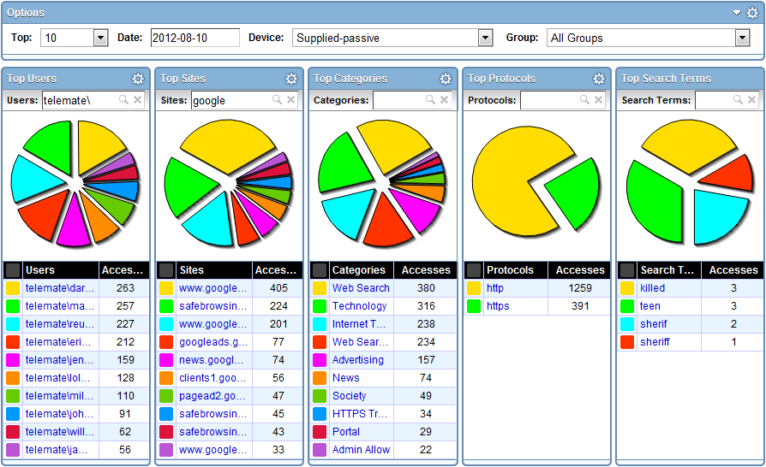

#### Trend-based Real-time Monitoring

NetAuditor includes trend-based monitoring and notification to provide real-time awareness of traffic patterns. Where the dashboard allows you to perform "Top N" searches of your processed data, the monitors allow you to tell the NetAuditor processing engine to watch for something specific as data is processed in real-time. You can check the monitor component at any time and instantly see all monitored traffic for the past 24 hours (down to 1-minute increments). You can set up alerts or event triggers to have the processing engine alert you immediately if the monitored traffic exceeds certain thresholds.

This feature is popular with our K12 customers for being used as a forensics tool. We recommend configuring monitors to track material such as search terms. A school may want to monitor sensitive search phrases such as Suicide, Bomb Making, Cyber Bullying, etc. These and any number of search terms can be monitored and then alerted on. Alerts can be tied to any monitor line and configured by day of week, number of accesses, threshold timeframe, and lead time. NetAuditor can then alert a manager through a number of ways such as email, text, HTTPS Get, or have a custom report sent.

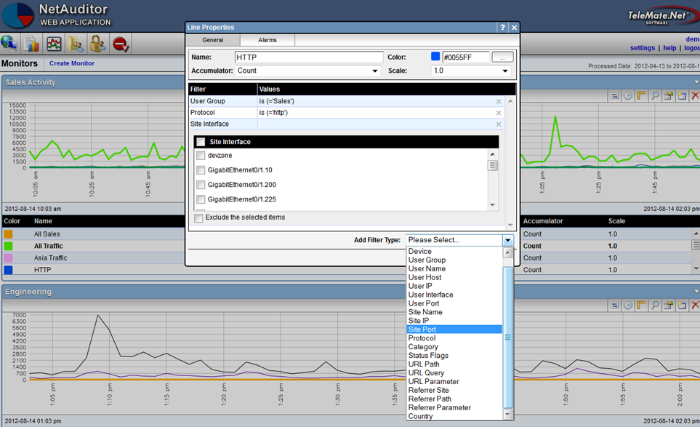

#### Security Management

User groups are important in NetAuditor for a number of reasons. In addition to providing a cleaner way to group/filter/search your users when viewing your network traffic, it is also the primary means of providing access control to your manager accounts. For example, if you want a teacher to be able to log into NetAuditor and set up reports and/or monitors on his students (without letting him see traffic generated by other classrooms, grades, or schools), you can set up a user group that exists for his class and then you can provide him with a manager account that only has access to that user group.

#### Automated Reporting

For more comprehensive information NetAuditor provides on-demand and automated reporting. Perhaps you found something in the dashboard you need more detailed information on. Perhaps you need more comprehensive summary/bandwidth reports, reports on firewall security alerts, traffic trends over time, or you want a PDF automatically generated every night/week/month for you to review. NetAuditor reporting provides several views to assist in managing reports and provides secured access.

Configuring reports enables an end-user to run, save, or schedule a new report. It will show you a list of all available report templates, which will be grouped by report categories. Properties exist for distributing via Email and FTP, and export formats include PDF, XLS, and HTML.

Filters are important to consider when configuring a report. If you have multiple groups or classrooms and you only want to see the data logged by one of them, specifying a filter on that group will make the report run faster and will make the resulting report smaller. When running detail reports, you could end up with a report that is too large to open. Omitting data from categories you aren’t interested in such as advertisements or society plugins will make your reports cleaner, only showing you the information you’re interested in seeing. This makes it easier to narrow down what a student has been surfing without having to waste time sifting through useless data. With over 40 reports and countless combinations of filters, you’ll always be able to narrow down your search to find the information you need.

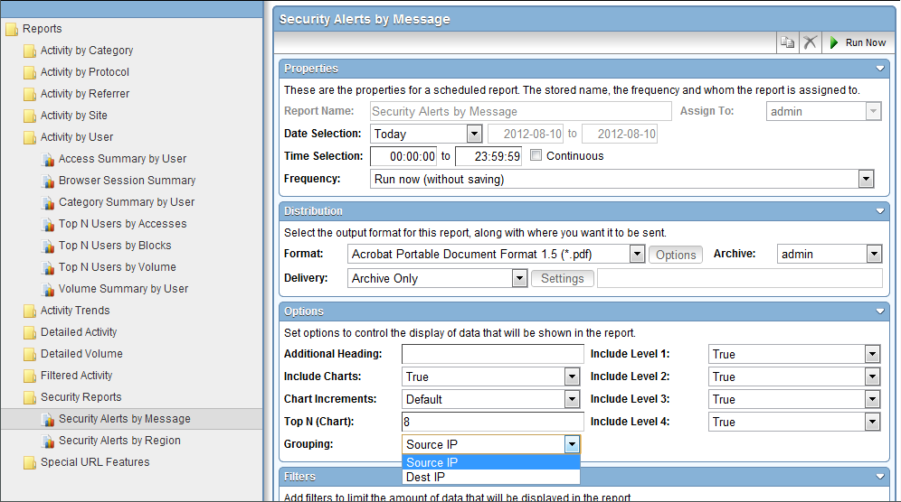

## 3.14 Diagnostic and Troubleshooting Features

### On the Box Statistics

NetSpective provides several built in, real time, 'gas gauge' type reports as well as the ability to view or search a recent portion of the traffic activity log for troubleshooting.

### Diagnostic Tool

Within NetSpective is our diagnostic tool designed primarily for support and development use. Contained within this tool is a number of reports for seeing how NetSpective is handling and processing web traffic.

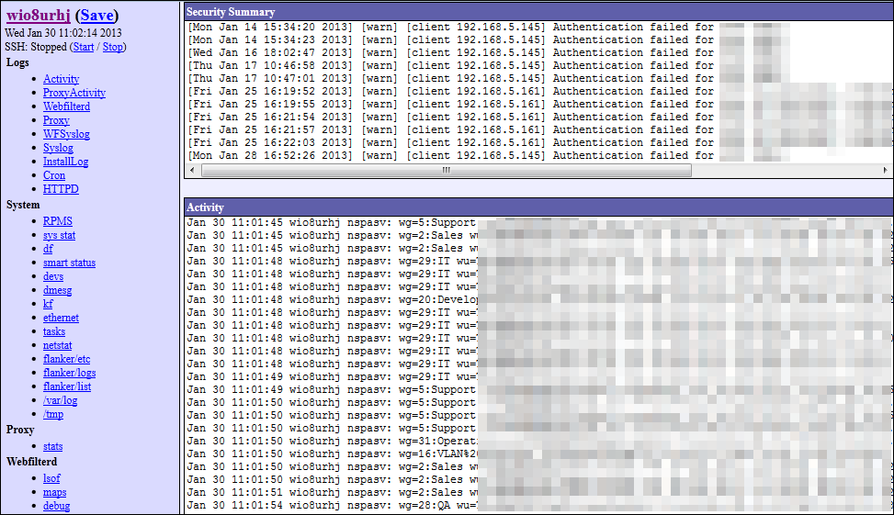

## 3.15 Support

TeleMate.Net Software offers a broad range of support, training, and consulting services designed to help you speed deployment and increase your efficiency, productivity and return on your technology investment.

Tier 2 and 3 support will be provided 24/7/365 and all hardware replacements are shipped overnight.

## 3.16 Additional Features

### Referrer Depth

Within the Overrides section is our Referrer Depth feature. With this, when an administrator whitelists a website, we have the ability to also allow any content linked to that site. With this anything linked to the website we are overriding will also be allowed, such as images linked from different web pages.

Many of our K12 customers found another use for this feature by poking pinhole access into YouTube. An administrator would whitelist a teacher’s personal webpage. The teacher would then add links to YouTube or another educational streaming media service. We would add this referrer depth feature to that teacher’s website, so that when a student would click on that link, they would go to YouTube and watch that video. If the student tried to access the same video through another means, like going directly through YouTube they would still be blocked.

### Abuse Detection

With our Abuse Detection, we have the ability to flag categories as level 1, 2, or 3 and then apply settings to those flagged categories. You can have an email notification sent, lock down all web traffic, or lock down all web and protocol activity. This can be based on the number of hits going to these flagged categories within a certain timeframe that you specify.

We find this really helps in the K12 space to curb a student’s surfing behavior when they find that there are bigger consequences to their actions. You could for example flag all of your peer-to-peer protocols. Then even if you are blocking access to those protocols, if a student is found attempting to access them, you could lock down all of their web and protocol access. The student would have no choice but to confess what they were doing in order to get their internet access turned back on. The student is then much less likely to exhibit that behavior again once they find there are bigger consequences to their actions.

### Override Request

If an administrator enables this feature, user will have the ability to request the category for a website be changed. A user will encounter a block page, view the category and website as reasons for why they were blocked, and can then click on the ‘request category change’ link. Once they make those requests, they can be seen in the Overrides section of the product. The administrator can then go in and view those requests, then decide if they want to re-categorize those websites or not.

## 3.17 Price

|  |  |  |
| --- | --- | --- |
| License | $22,000 per Year | $66,000 for 3 Years |
| NetSpective Passive 1Gig 6Q Appliance | $3,000 |  |
| NetSpective Passive 10Gig 6Q Appliance | $7,000 |  |
| Software as a Service | $25 per User |  |

## 3.18 References

Paul Chavez

Region XIII ESC

Voice: 512 919-5303

Fax: 512 919-5395

[Paul.Chavez@esc13.txed.net](mailto:Paul.Chavez@esc13.txed.net)

<http://www.esc13.net>

Tim Smith

Region 16 Education Service Center

Wide Area Network Administrator

806-677-5254

[tim.smith@esc16.net](mailto:tim.smith@esc16.net)

<http://www.esc16.net>

# Tab D – Cost Proposal

|  |  |  |  |  |  |  |  |  |  |  |  |  |  |
| --- | --- | --- | --- | --- | --- | --- | --- | --- | --- | --- | --- | --- | --- |
|  |  |  |  |  |  |  |  |  |  |  |  |  |  |
|  | tmnt   |  | | --- | |  | |  |  | **Enterprise Products  Order Confirmation** | | | | |  |  |  |  |  |
|  |  |  |  |  |  |  |  |  |
|  |  |  |  |  |  |  |  |  |  |  |  |  |  |
|  |  |  |  |  |  |  |  |  |  |  |  |  |  |
|  |  |  |  |  |  |  |  |  |  |  |  |  |  |
|  | By executing below, the below named company (“Customer”) agrees to purchase, and TeleMate.Net Software, LLC.(TeleMate) agrees to sell, the non-Software Products ordered below and a limited license for the Software Products ordered below, all in accordance with and subject to the attached terms and conditions (the “Terms and Conditions”). Furthermore, if Customer elects below to purchase the Software Maintenance Plan, TeleMate will provide maintenance of the Software, subject to the terms and conditions of the Software Maintenance Plan attached hereto (the “Maintenance Plan”). This Order Confirmation, the Terms and Conditions, and, if purchased, the Maintenance Plan, constitute the entire agreement of the parties (the “Agreement”), which TeleMate and Customer hereby execute below as of the “Effective Date” indicated below. | | | | | | | | | | | | |
|  |  |  |  |  |  |  |  |  |  |  |  |  |  |
|  | **DELIVER TO:** |  | UEN | | | **FROM:** | |  | James Wooden | | | | |
|  |  |  |  | | | **Return Fax to:** | |  | james.wooden@telemate.net | | | | |
|  |  |  |  | | | **Fax Number:** | |  | +1 (678) 589-7110 | | | | |
|  |  |  |  | | |  |  |  |  |  |  |  |  |
|  |  |  |  |  |  |  |  |  |  |  |  |  |  |
|  | Please review the information below, make any necessary corrections, sign and date the Order Confirmation and fax to the TeleMate contact designated above. TeleMate will process the order upon receipt of the signed Order Confirmation. | | | | | | | | | | | | |
|  |  |  |  |  |  |  |  |  |  |  |  |  |  |
|  |  |  |  |  |  |  |  | | | | | | |
|  | **Bill to:** |  | UEN | | |  | **Alternate Shipping or A/P Address (if different site)** | | | | | | |
|  | **Address:** |  |  | | |  |  | | | | | | |
|  |  |  |  | | |  |  | | | | | | |
|  |  |  |  | | |  |  | | | | | | |
|  |  |  |  | | |  | **For shipping purposes, please include a telephone number:** | | | | | | |
|  |  |  |  | | |  |  | | | | | | |
|  |  |  |  | | |  | **Shipping or A/P Contact:** | | |  | | | |
|  |  |  |  | | |  |  | | | | | | |
|  | **Quote Expiration:** |  |  | | |  | **Telephone Number:** | | |  | | | |
|  | **Comment:** |  | 1 GIG Appliance - $3,000.00 | | |  |  | | | | | | |
|  |  |  | 10 GIG Appliances - $7,000.00 | | |  | **Registration Email:** | | |  | | | |
|  |  |  | 2 Year Extension - $40,000.00 | | |  |  | | | | | | |
|  |  |  |  | | |  |  | | | | | | |

|  |  |  |  |  |  |  |  |  |  |  |  |  |  |
| --- | --- | --- | --- | --- | --- | --- | --- | --- | --- | --- | --- | --- | --- |
|  |  |  |  |  |  |  |  |  |  |  |  |  |  |
|  | **Item** | | | | **Unit Price** | | **Quantity** | **Shipping** | | **Tax %** | **Total** | | |
|  |
|  | NetSpective Unlimited License | | | | $22,000.00 | | 3 | $75.00 | | 0% | $66,000.00 | | |
|  |  | | | |  | |  |  | |  |  | | |
|  |  | | | |  | |  |  | |  |  | | |
|  |  | | | |  | |  |  | |  |  | | |
|  |  | | | |  | |  |  | |  |  | | |
|  |  | | | |  | |  |  | |  |  | | |
|  |  | | | |  | |  |  | |  |  | | |
|  |  | | | |  | |  |  | |  |  | | |
|  |  | | | |  | |  |  | |  |  | | |
|  |  | | | |  | |  |  | |  |  | | |
|  |  | | | |  | |  |  | |  |  | | |
|  |  | | | | | | | | | | | | |
|  |  |  |  |  |  |  | Software & Hardware Total | | |  | $66,000.00 | | |
|  |  |  |  |  |  |  | Shipping | | |  | $75.00 | | |
|  |  |  |  |  |  |  | Options Total (see below) | | |  | $0.00 | | |
|  |  |  |  |  |  |  | Sales Tax | | |  | $0.00 | | |
|  |  |  |  |  |  |  | Total Sale | | |  | $66,075.00 | | |
|  |  |  |  |  |  |  |  |  |  |  |  |  |  |

|  |  |  |  |  |  |  |  |  |  |  |  |  |  |
| --- | --- | --- | --- | --- | --- | --- | --- | --- | --- | --- | --- | --- | --- |
|  |  |  |  |  |  |  |  |  |  |  |  |  |  |
|  | tmnt   |  | | --- | |  | |  |  | **Enterprise Products  Order Confirmation** | | | | |  |  |  |  |  |
|  |  |  |  |  |  |  |  |  |
|  |  |  |  |  |  |  |  |  |  |  |  |  |  |
|  |  |  |  | **Options Total** | | | | |  |  |  |  |  |
|  |  |  |  |  |  |  |  |  |  |  |  |  |  |
|  |  |  |  |  |  |  |  |  |  |  |  |  |  |
|  | **NETSPECTIVE ONLY:** | | |  |  |  |  |  |  |  |  |  |  |
|  |  | Term of Agreement: | | |  |  | Number of Permitted End Users: | | |  |  | | |
|  |  |  |  |  |  |  |  |  |  |  |  |  |  |
|  | **TELEMATE ONLY:** |  |  |  |  |  |  |  |  |  |  |  |  |
|  |  | PBX Type: | |  |  |  |  |  |  |  |  |  |  |
|  |  |  |  |  |  |  |  |  |  |  |  |  |  |
|  |  |  |  |  |  |  |  |  |  |  |  |  |  |
|  |  |  |  |  |  |  |  |  |  |  |  |  |  |
|  | **Options (Customer to initial if to include any of the options below in this order):** | | | | | | | |  |  |  |  |  |
|  |  |  |  |  |  |  |  |  |  |  |  |  |  |
|  | **Option 1** |  |  |  |  |  |  |  |  |  |  |  |  |
|  | Installation and Training Assistance | | | | **0** | Days at daily rate of | | | $0.00 | | per day |  |  |
|  |  |  |  |  |  |  |  |  |  |  |  |  |  |
|  |  |  |  |  |  |  | **Totaling** | | |  | **$0.00** | | |
|  |  |  |  |  |  |  |  |  |  |  |  |  |  |
|  | A) The installation and training fees set forth above do not include travel and other reasonable expenses, which if incurred by TeleMate, will be invoiced separately.  B) Customer must make all necessary arrangements to receive the installation and training assistance within 60 days from receipt of the Product or any installation and training assistance ordered will be cancelled. | | | | | | | | | | | | |
|  |
|  |  |  |  |  |  |  |  |  |  |  |  |  |  |
|  |  |  |  |  |  |  |  |  |  |  |  |  |  |
|  | **Option 2** |  |  |  |  |  |  |  |  |  |  |  |  |
|  | The following additional options not listed above: | | | | |  |  |  |  |  |  |  |  |
|  |  |  |  |  |  |  |  |  |  |  |  |  |  |
|  |  | | | | | | | | |  | $0.00 | | |
|  |  | | | | | | | | |  | $0.00 | | |
|  |  | | | | | | | | |  | $0.00 | | |
|  |  | | | | | | | | |  | $0.00 | | |
|  |  | | | | | | | | |  | $0.00 | | |
|  |  | | | | | | | | |  | $0.00 | | |
|  |  |  |  |  |  |  | **Totaling** | | |  | **$0.00** | | |
|  |  |  |  |  |  |  |  |  |  |  |  |  |  |
|  |  |  |  |  |  |  |  |  |  |  |  |  |  |
|  | **Customer’s Purchase Order Number**, if required: | | | |  |  | |  |  |  |  |  |  |
|  |  |  |  |  |  |  |  |  |  |  |  |  |  |
|  |  |  |  |  |  |  |  |  |  |  |  |  |  |
|  |  |  |  |  |  |  |  |  |  |  |  |  |  |
|  | tmnt   |  | | --- | |  | |  |  | **Enterprise Products  Order Confirmation** | | | | |  |  |  |  |  |
|  |  |  |  |  |  |  |  |  |
|  |  |  |  |  |  |  |  |  |  |  |  |  |  |
|  |  |  |  | **Terms and Conditions** | | | | |  |  |  |  |  |
|  |  |  |  |  |  |  |  |  |  |  |  |  |  |
|  | Payment and Taxes:   1. Customer will pay to TeleMate the fees described above. Unless otherwise provided above, such fees and other amounts due under the Agreement will be payable within thirty (30) days of receipt of an invoice from TeleMate, without any right of set-off. Customer will make all payments in US Dollars. Customer will pay a late charge equal to the lesser of one and one-half (1.5) percent per month or the highest interest rate allowed by applicable law on all amounts not paid when due from the due date of such amounts until such amounts have been paid by Customer. If TeleMate incurs any costs to collect delinquent payments, or to otherwise enforce the terms of the Agreement, then Customer will pay all of such costs when invoiced by TeleMate, including, without limitation, attorney fees and court costs. Customer acknowledges that the Product is valuable to TeleMate and valuable to other customers of TeleMate and that all customers pay a fee for access and use of the Product. Therefore, Customer agrees not to engage in any conduct that may allow Customer or other customers to circumvent paying fees to TeleMate. | | | | | | | | | | | | |
|  |  |  |  |  |  |  |  |  |  |  |  |  |  |
|  | 2. All fees payable to TeleMate are exclusive of any taxes, assessments or duties that may be assessed upon the Product, the Documentation (as defined in the Terms and Conditions), or the licenses granted under the Agreement, including, without limitation, sales, use, excise, value-added, personal property, electronic/Internet commerce, export, import and withholding taxes. Customer will directly pay when due any such taxes assessed against it, and Customer will promptly reimburse TeleMate for any such taxes payable or collectable by TeleMate. Such taxes do not include taxes based upon TeleMate’s income. The order confirmation terms stated herein supersede any and all purchasing documentation including purchase orders. | | | | | | | | | | | | |
|  |  |  |  |  |  |  |  |  |  |  |  |  |  |
|  | **Remittance** | | | | | | | | | | | | |
|  |  |  | FEID: | | 26-3330752 |  |  |  |  |  |  |  |  |
|  |  |  | Company | | TeleMate.Net Software | | |  |  |  |  |  |  |
|  |  |  | Address: | | 5555 Triangle Parkway | | |  |  |  |  |  |  |
|  |  |  |  | | Suite 150 | | |  |  |  |  |  |  |
|  |  |  |  | | Atlanta, Georgia 30092 USA | | |  |  |  |  |  |  |
|  |  |  | Phone: | | (678) 589-7100 |  | (678) 589-7110 (fax) |  |  |  |  |  |  |
|  |  |  | Email: | | Accountspayable@TeleMate.net | | |  |  |  |  |  |  |
|  |  |  |  |  |  |  |  |  |  |  |  |  |  |
|  | **All transactions pursuant to an executed Order Confirmation are final and are not subject to return or credit, EXCEPT AS SPECIFICALLY PROVIDED IN THE TERMS AND CONDTIONS.** | | | | | | | | | | | | |
|  |  |  |  |  |  |  |  |  |  |  |  |  |  |
|  | **Accepted by Customer:** | | |  | |  | **Accepted by TeleMate:** | |  | | | | |
|  |  |  |  | (Signature) |  |  |  |  |  | (Signature) |  |  |  |
|  | **Please Print Name:** | | |  | |  | **Please Print Name:** |  |  | | | | |
|  |  |  |  |  |  |  |  |  |  |  |  |  |  |
|  | **Title:** |  |  |  | |  | **Title:** |  |  | | | | |
|  |  |  |  |  |  |  |  |  |  |  |  |  |  |
|  |  |  |  |  |  |  | **Effective Date:** |  |  | | | | |
|  |  |  |  |  |  |  |  |  |  |  |  |  |  |
|  |  |  |  |  |  |  |  |  |  |  |  |  |  |
|  |  |  |  |  |  |  |  |  |  |  |  |  |  |

# Tab E – Financial Reports

TeleMate.Net Software, LLC

**Balance Sheet**

As of December 31, 2012

|  |  |
| --- | --- |
| ASSETS | |
| Current Assets | |
| Checking/Savings | |
| 00000 • Bank - combined | |
| 05000 • Wells Fargo Savings | 1,000.56 |
| 01000 • BofA - Checking 6222 | -2,481.16 |
| 02000 • BofA - Secondary Checking 7857 | 236.99 |
| 03000 • Wachovia - Checking x4189 | 1,000.00 |
| 00000 • Bank - combined - Other | -249.75 |
| Total 00000 • Bank - combined | -493.36 |
| Total Checking/Savings | -493.36 |

|  |  |
| --- | --- |
| Accounts Receivable | |
| 11000 • Accounts Receivable | 221,340.44 |
| 11500 • Pre-Acquisition A/R | 1,475.99 |
| Total Accounts Receivable | 222,816.43 |

|  |  |
| --- | --- |
| Other Current Assets | |
| 12100 • Inventory Asset | 3,664.00 |
| 12200 • Employee Advances | 6,085.60 |
| Total Other Current Assets | 9,749.60 |
| Total Current Assets | 232,072.67 |

|  |  |
| --- | --- |
| Fixed Assets | |
| 15000 • Furniture and Equipment | |
| 17000 • Accumulated Depreciation | -55,775.34 |
| 15000 • Furniture and Equipment - Other | 212,557.25 |
| Total 15000 • Furniture and Equipment | 156,781.91 |
| Total Fixed Assets | 156,781.91 |

|  |  |
| --- | --- |
| Other Assets | |
| 16000 • Purchased IP (Software) | |
| 16100 • Purchased Telemate Software | 790,000.00 |
| 16200 • Purchased NetSpective Software | 590,010.00 |
| 16300 • Net Auditor Software | 42,970.00 |
| Total 16000 • Purchased IP (Software) | 1,422,980.00 |
| 19000 • Security Deposit - Lease | 18,642.50 |
| Total Other Assets | 1,441,622.50 |
| TOTAL ASSETS | 1,830,477.08 |

|  |  |
| --- | --- |
| LIABILITIES & EQUITY Liabilities | |
| Current Liabilities | |
| Accounts Payable | |
| 20000 • Accounts Payable | 3,597.18 |
| Total Accounts Payable | 3,597.18 |
| Other Current Liabilities |  |
| 22000 • Deferred Maintenance | 1,717,418.87 |
| 25500 • Sales Tax Payable | -140.00 |
| 26000 • Deferred Revenue - Current | 0.60 |
| 28000 • Loans | |
| 28100 • Officer Loan | 175,500.00 |
| 28000 • Loans - Other | -3,000.00 |
| Total 28000 • Loans | 172,500.00 |
| Total Other Current Liabilities | 1,889,779.47 |
| Total Current Liabilities | 1,893,376.65 |
| Total Liabilities | 1,893,376.65 |

|  |  |
| --- | --- |
| Equity | |
| 30000 • Opening Bal Equity | 12,938.00 |
| 31000 • Class I Members | |
| 31100 • Steven Tabaska | 1,920,400.00 |
| Total 31000 • Class I Members | 1,920,400.00 |
| 32000 • Retained Earnings | -689,309.04 |
| 33000 • Distribution | |
| 33100 • Distribution to ST | -59,500.00 |
| 33200 • Distribution to JO | -21,000.00 |
| 33000 • Distribution - Other | -650,000.00 |
| Total 33000 • Distribution | -730,500.00 |
| Net Income | -576,428.53 |
| Total Equity | -62,899.57 |
| TOTAL LIABILITIES & EQUITY | 1,830,477.08 |